Instructions for author: writing an abstract to be submitted to
EUROMECH Colloquium 661

First A. Author, Presenting Author and Third B.C. Author

Write affiliation here. If you need more than one affiliation use numbering.

This document will help you prepare your abstract of maximum 1 page, including figures, equations and references for the EUROMECH Colloquium 661 “Rate effects in contact mechanics of soft solids: adhesion, friction, damping”. Please use exclusively this template to write your abstract as it contains all the necessary styles and page set-up and is ready to use.

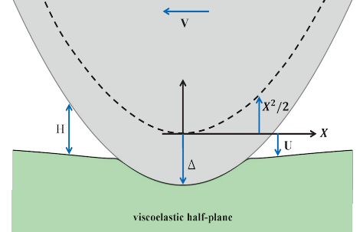 | 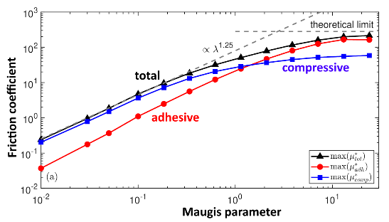
(a) | (b)
Figure 1: (a) Schematic of a sliding Hertzian contact. (b) contribution to the friction coefficient depending on the Maugis parameter.

Set-up: Font is Times New Roman. Use A4 paper with top and bottom margins of 2.54 cm (1 inch) and left and right margins of 3.17 cm (1.25 inches). Do not include page numbers nor page header/footer. Footnotes are not allowed.
Title: The title is typed in bold, 14pt, centered. Do not capitalize words in the title, except the first word of the title or proper nouns. Between title and authors list there is a blank line.
Authors: The authors are listed in one paragraph in 12pt, centered. Put first name, initials and last name. Use super-scripted numbering if authors have a different affiliation.
Affiliation: Affiliation and e-mail address are in 10pt, italic, centered. Different affiliations are put in separate paragraphs and numbered with the super-scripted numbers used in the authors list. If no e-mail address is available, add a fax-number.
Body text: The remainder of the abstract is made of paragraphs, (no numbered sections) justified at both left and right margins and in 11pt.
References: numbered as [1], [2, 3], [1-3] and listed in numerical order following the text body. Work accepted for publication should be referred as “in press”. References to unpublished data cannot be cited. Reference list is in 10pt.
References
- Papangelo, A., Nazari, R., & Ciavarella, M. (2024). Friction for a sliding adhesive viscoelastic cylinder: Effect of Maugis parameter. European Journal of Mechanics-A/Solids, 107, 105348.
- Vakis, A. I., Yastrebov, V. A., Scheibert, J., Nicola, L., Dini, D., Minfray, C., ... & Ciavarella, M. (2018). Modeling and simulation in tribology across scales: An overview. Tribology International, 125, 169-199.
- Barber, J. R. (2018). Contact mechanics (Vol. 20). Berlin: Springer International Publishing.

